SECOND POSTING

Request for Qualifications

Stormwater Planning Study

LeGrand Center

RFQ-2023 LC SWP

May 3, 2023

Cleveland County Administrative Building
Attn: Emily Sisk
Finance & Purchasing Department
311 E. Marion St
Shelby, NC 28150
Office: 704-669-4130
Email: Emily.Sisk@clevelandcountync.gov

Stormwater Planning Study
LeGrand Center

Table of Contents

1. Introduction 3
2. Overview 4
3. Project Details 4
4. General Requirements 5
5. Firm’s Affirmations 5
6. Submission Requirements 7
7. Expected Deliverables and Scope of Work 7
8. Included in Qualifications: 7
9. Appendix 9
10. RFQ Form 12

- Introduction
Cleveland County Government requests qualifications of engineering firms to provide specified professional services in connection with a Stormwater Planning Study for LeGrand Center.

The submittal deadline is 05/11/2023 by 10:00 am.

The firm’s qualification package shall be submitted as an electronic PDF (file size not to exceed 15MB).
Qualification packages can be submitted by any one of the following methods:

Electronic: Emily.Sisk@clevelandcountync.gov
Subject Line: “RFQ-2023 LC SWP”

Mail (USB drive)*: Cleveland County
Finance & Purchasing Department
Attn: Tonya Brittain
PO Box 1210
Shelby, NC 28151
*Must be received by the submittal deadline date listed above.

Administrative questions can be emailed to Tonya Brittain at: Tonya.Brittain@clevelandcountync.gov

Project scope questions should be emailed to: Emily.Sisk@clevelandcountync.gov no later than 05/08/2023.

Firms who submitted by the first deadline of 04/30/2023 are not required to resubmit their packet.

- Overview
Cleveland County Government and its partners constructed LeGrand Center more than a decade ago in response to capacity needs for several public programs and large conference space. A perennial stream near LeGrand Center is impacted by stormwater quality and quantity. Cleveland County is interested in contracting with a reputable firm to complete a stormwater planning study to answer the following questions:
- What are the existing conditions of the stream, stormwater, and the surrounding area’s impact?
- What are the options for stream restoration and stormwater control alternatives in response to current and anticipated development activities in the surrounding area?
The anticipated fees for this type of project should be reasonably based on similar projects with similar requirements.
Funding for this project originates from Federal American Rescue Plan Act (ARPA) and must meet applicable federal law and guidance. The following guidance is provided:
Engineering Services Procurement
The Uniform Guidance 2 CFR 200.317 through 2 CFR 200.327 gives minimum requirements for procurement, with 2 CFR 200.319(b) addressing engineering services procurement guidelines. ARP-funded projects must also adhere to North Carolina State law, specifically NC General Statute 143-64.31, Article 3D Procurement of Architectural, Engineering, and Surveying (A/E) Services. NCGS 143-64.32 cannot be used to exempt Recipients from a qualification-based selection for A/E. The State provides applicable certification forms that must be completed prior to receiving funds for any engineering services covered under this funding offer.
Cleveland County will choose a qualified firm based on guidance from the North Carolina Department of Environmental Quality (NC DEQ) in Appendix-“ARPA-Funded Projects and Engineering Services Procurement.”

Cleveland County will conduct a technical evaluation of the proposals received and make a selection based on, but not limited to, the criteria below:

- Overall reputation of the firm/team
- Key team members — experience and qualifications
- Project references specific to this type of service
- Experience with applicable regulatory agencies and permitting
- Experience with providing these services to local governments
- General project understanding
- Proposed fees/general cost analysis
- Unique qualities that would make firm/team best suited for the project
- Proposed team members
- Project Details
Cleveland County Government is seeking qualifications statements from qualified firms to provide design and engineering services to complete a stormwater planning study reflecting current and future options for stream restoration, landscape architectural, environmental design, hydraulic modeling, stormwater control measures, management plan, and other recommended stormwater management assessments of the identified site.
Identified Site: LeGrand Center, 1800 E. Marion Street, Shelby, NC 28152, approximately 600 linear feet (LF) of perennial stream at 35.27835, -81.48864 (Latitude, Longitude); per USGS, the watershed is 0.0821 square miles (52.5 acres).
Surrounding Use: The perennial stream is surrounded by several buildings and parking areas including, but not limited to: LeGrand Center, LeGrand Center parking (front and rear); Cleveland Community College Bailey Allied Health and Science Center and parking, Petty Amphitheatre, Student parking lots; East Marion Street; Cleveland County Fairgrounds
Additional Information: The perennial stream is 600 LF and is impacted by rain that falls directly on the project area, and includes rain coming from drop-outlets from parking lots, roads, and buildings that contribute surface water runoff. Nearly 96% of the watershed is developed (urban) land, according to the US Geological Survey StreamStats.
- General Requirements
  - The RFQ contact form must be signed and returned with firm’s proposal package for the services and deliverables described in Schedule 7 (the “Scope of Work”).
  - The County will not be bound to act by any communication or proposal submitted by firms other than in accordance with this RFQ.
  - Firm’s questions and the County’s responses may or may not be forwarded to all firms. The County reserves the right to communicate all or part of the questions and responses, with all, or certain firms.
  - By submitting a proposal package in response to this RFQ, firm is deemed to accept the award selection process and criteria and County’s discretion in connection with such process and criteria.
  - By submitting a proposal package in response to this RFQ, the firm acknowledges and waives any claim for compensation of any kind whatsoever against the County or any of its Representatives (as defined below), as a result of its submission, any decision made by the County during the RFQ process, including when acting in its sole discretion, or arising in any other manner from its participation in this RFQ.
- Firm’s Affirmations
  - By submitting its qualifications, the firm represents and warrants the following:
    - This RFQ is a solicitation for professional proposals and is not a contract or an offer to contract.
    - The submission of a proposal package by the firm in response to this RFQ will not create a contract between the County and firm.
  - The County makes no representation or warranty, written or oral, that one or more contracts will be awarded under this RFQ; and
  - The firm will bear, as its sole risk and responsibility, any cost arising from firm’s preparation of a response to this RFQ and, as applicable, contract negotiations.
  - The firm is a reputable person that is lawfully and regularly engaged in providing and/or performing the Professional Services.
  - The firm has the necessary experience, knowledge, abilities, skills, and resources to provide the Deliverables and/or perform the Professional Services upon the terms and conditions specified in this RFQ.
  - The firm is aware of, is fully informed about, and is in full compliance with all applicable federal, state and local laws, rules, regulations and ordinances including, without limitation, those relating to bid rigging.
  - The firm understands:
    - The requirements and specifications set forth in this RFQ and
    - The terms and conditions set forth under which the firm will be required to operate.
  - If selected by the County, the firm will not delegate any of its duties or responsibilities under this RFQ or any resulting contract to any subcontractor, except as expressly provided in the qualifications.
  - If selected by the County, the firm will maintain any insurance coverage required by the contract during the term thereof.
  - All statements, information and representations prepared and submitted in response to this RFQ are current, complete, true and accurate. The firm acknowledges that the County will rely on such statements, information and representations in selecting the successful professional services provider. If selected by the County, the firm will notify the County immediately of any material change in any matters regarding the firm’s responses to questions asked by the county, any documentation the firm has provided or any change that would materially impact the firm’s ability to execute and complete the project as agreed upon.
  - The firm has not given or offered to give to the County or any of its Representatives nor does it intend to give at any time hereafter, any economic opportunity, future employment, gift, loan, gratuity, special discount, trip, favor or service in connection with its submitted quotation.
  - The firm certifies that other than the relationships which have been previously disclosed to the County in writing:
    - No relationship, whether by blood, marriage, business association, capital funding agreement or any other such kinship or connection exists between the owner of any firm that is a sole proprietorship, the officers or directors of any firm that is a corporation, the partners of any firm that is a partnership, the joint ventures of any firm that is a joint venture or the members or managers of any firm that is a limited liability company, on one hand, and an employee of any affiliate of the County, on the other hand, and
    - The firm or any of its officers, directors and shareholders/partners has not been an employee of the County within the immediate twelve (12) months prior to the submittal deadline of this RFQ. All disclosures by firm in connection with this certification will be subject to administrative review and approval before the County enters into a purchase order, contract or agreement with firm.
  - The firm represents and warrants that no proceedings have been taken or authorized by it or by any other person with respect to the bankruptcy, insolvency, liquidation, dissolution or winding up of the firm nor, to the knowledge of the firm, has anyone threaten to take any such proceedings against it.
- Submission Requirements
  - Contact: All completed documents constituting your proposal, as well as any questions or clarifications concerning this RFQ must be submitted to the County’s representative identified on page 3 of this RFQ.
  - Timeline: The proposal package must be received on or before the submittal deadline (date and time) specified on page 3 of this RFQ. The County reserves the right, but has no obligation, to accept a qualification package submitted after the deadline and to amend the timeline. If a change to the timeline is required, the County will communicate the change to the firm(s). If a firm requests an extension of a deadline, the County may, in its sole discretion, decide to allow the extension or not. The County may, in its sole discretion, decide whether or not to communicate to the other firm(s) it granting of an extension or to offer them with the same extension.
- Expected Deliverables and Scope of Work
Expected deliverables include, but are not limited to, an assessment report of the watershed to predict hydrology for the stream reaches and stormwater conveyances and control measures on the property, stream stability assessment to document erosion conditions, stream functional assessment, concept-level design alternatives showing channel and floodplain cross-sections, stream planform and profile, in-stream rock and/or log structures, stormwater outfall enhancements, retention systems, and native riparian vegetation, documentation of community benefits for recreation and education, planning-level cost estimates for restoration components. Assessments of existing and potential stream restoration and stormwater control measure performance (e.g. BANCS, SQT, BEHI, NBS, etc.).
  - Phase 1 – Preliminary Project Scope, due May 26, 2023, that includes a cost estimate and schedule for each major task associated with this Stormwater Planning Study.
  - Phase 2 – Existing Conditions Assessment, due TBD
  - Phase 3 – Conceptual Design of Stream Restoration and Stormwater Control Alternatives, due TBD
- Included in Qualifications:
  - List of recent applicable stormwater projects with:
    - A brief description of firm’s role.
    - Pictures or 3-D renderings of any applicable projects.
    - Three to five client references and contact information.
  - Project organization
    - Team organization chart with names and functions.
    - List of team members’ relative work experience.
    - Proposed project execution plan with milestones and schedule for completion.
  - Cost of Services
    - Estimated Total Cost of Stormwater Planning Study
    - Project Scope to Include Cost Estimate and Schedule for Each Major Task
    - List any alternate or optional services (including costs broken out from project total)
    - Miscellaneous

- Appendix

APPENDIX

“ARPA-Funded Projects and Engineering Services Procurement.”
Source: NC DEQ Division of Water Infrastructure Guidance, date: February 28, 2022
LINK
(https://www.deq.nc.gov/water-infrastructure/engineering-services-arpa-funded-projects/open)

Site Information and Photos (Next Page)

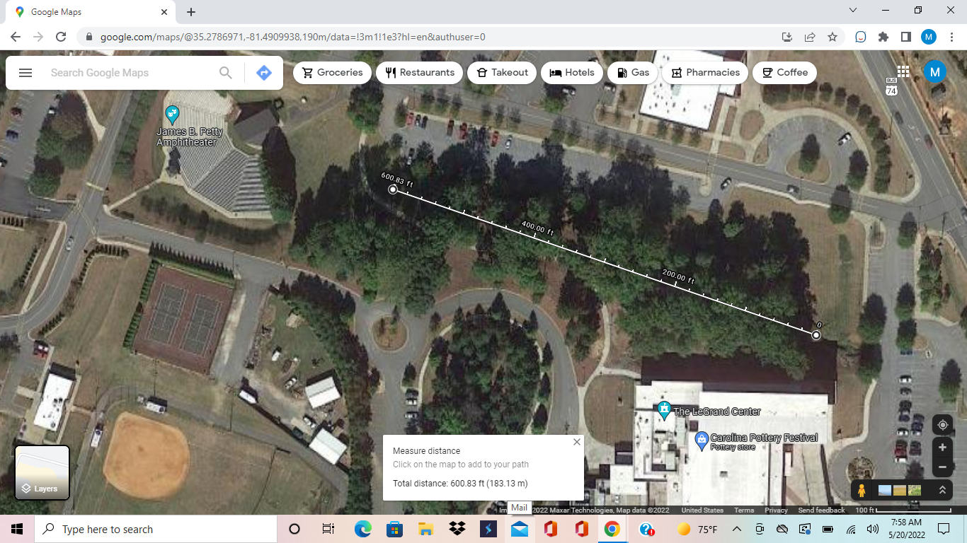
Site Information and Photos (September 2022)
Project Site

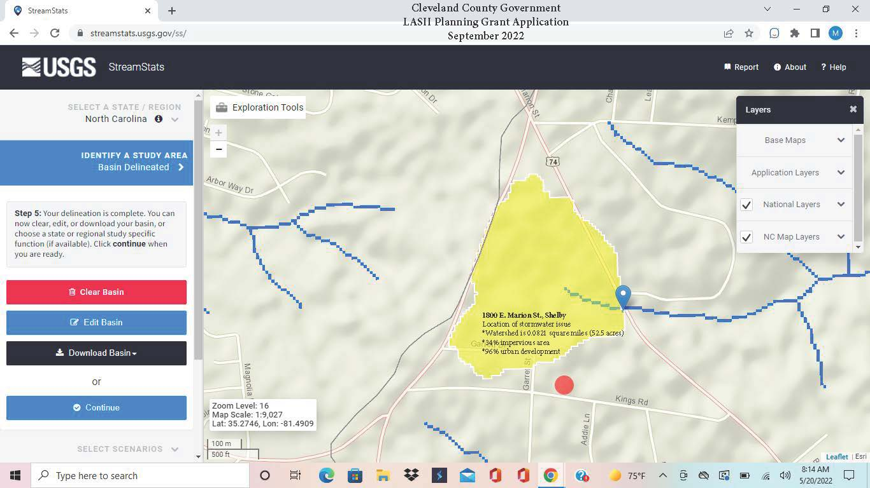
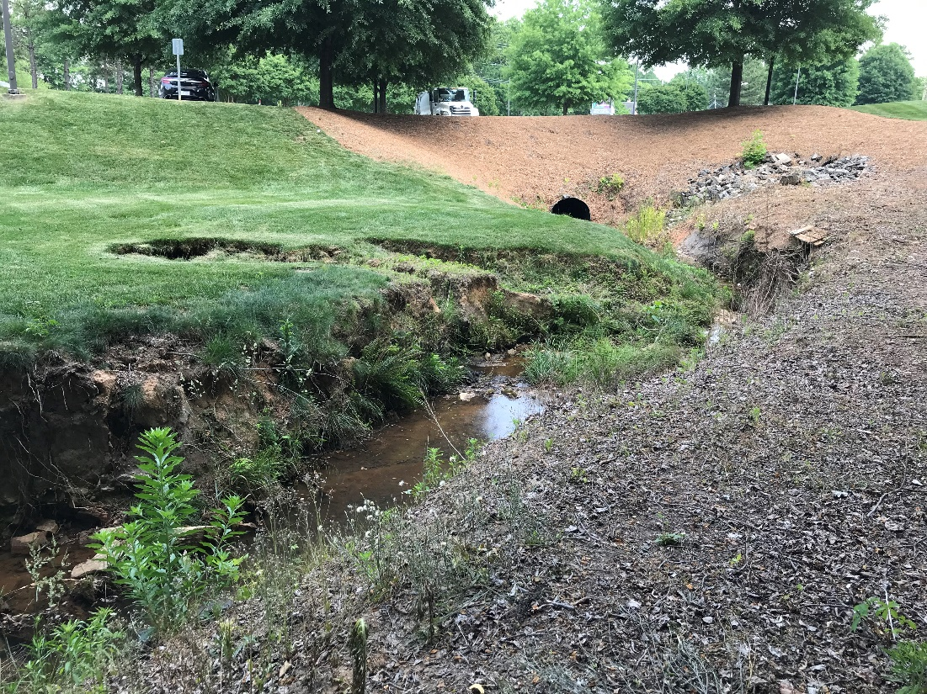
Image 1: Perennial Stream at LeGrand Center

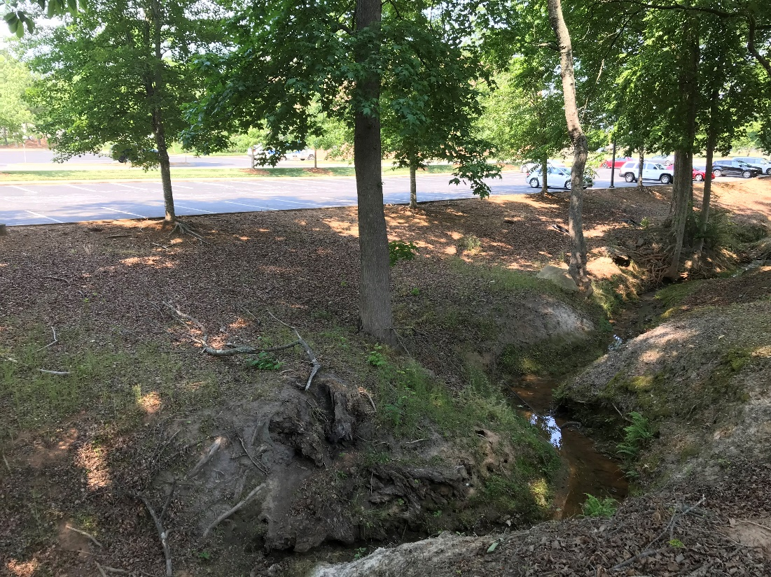
Image 2: Perennial Stream and Adjacent Parking

- RFQ Form
To: Cleveland County Finance & Purchasing Department
PO Box 1210
ATTN: Tonya Brittain
311 E. Marion Street
Shelby, NC 28151

From: _________________________________ Date: _______________________
_________________________________
_________________________________
_________________________________

Principal Contact Information

__________________________________
Signature

___________________________________
Print Name

___________________________________
License Number

___________________________________
Expiration Date

___________________________________
Company Name
___________________________________
Company Address Line 1

___________________________________
Company Address Line 2

___________________________________
Work Phone

___________________________________
Cell Phone

___________________________________
Email

